**START SHEET**

**Chelmer_lion_09_AW**

**CHELMER CYCLING CLUB**

**OPEN SCRATCH 25 MILE TT**

|  |
| --- |
| **SUNDAY 28TH JULY 2024 – START 08:01AM ON THE COURSE E9/25**  **HQ: CHELMER CLUB HUT; METEOR WAY, OFF WATERHOUSE LANE, CHELMSFORD CM1 2RL**  **TIMEKEEPERS: JOHN COTTEE AND PETER SMITH** |

**EVENT SECRETARY: PAUL DONEGAN –** [**paul\_donegan@hotmail.com**](mailto:paul_donegan@hotmail.com) **07789 774 990**

**THIS EVENT COUNTS TOWARDS THE SPOCO SE**

**ALSO INCORPORATING THE SOUTHEND WHEELERS Vs CHELMER CC INTERCLUB FOR THE BOB HAWORTH TROPHY**

**AWARDS:**

**TT BIKES: Road Bikes:**

**OPEN 1st: £30 OPEN 1st: £30**

**OPEN 2nd: £20 OPEN 2nd: £20**

**OPEN 3rd: £10 OPEN 3rd: £10**

**WOMEN 1st: £30 WOMEN 1st: £30**

**WOMEN 2nd: £20**

**WOMEN 3rd: £10**

**Riders will be eligible for awards in the category that they have entered on the CTT Website only. Once the start sheet has been issued, there can be no alterations.**

**Course details: E9/25**

**Start (GR 677076) on the A1060 at the western edge of drain adjacent to T.P.260 which is 210 yards west of Lordship Road (approximately 2.5 miles west of Chelmsford). Proceed along A1060 through Margaret Roding to Leaden Roding (M)(6.85m). Turn right WITH GREAT CARE onto the B184 and continue through High Roding to turn around the roundabout at Clopton Hall Lane (M)(12.6m). Retrace through High Roding and Leaden Roding (M)(18.35m), turn along the A1060 through Margaret Roding to FINISH (GR 675076) at a drain which is opposite the entrance to “Valley Way” bungalow. Parking must not be on the A1060 but in an old road opposite and 0.5m before the finish.**

**PLEASE NOTE: REGULATION FOR LEADEN ROADING RAB**

**Any rider passing to the right of the painted circle at Leaden Roding mini roundabout will be disqualified from the event and reported to the District Secretary for consideration of disciplinary action.**

**ADDITIONAL NOTES TO RIDERS:** The following regulations **MUST** be adhered to:

1. No riding with your head down, any rider observed riding dangerously will be disqualified from the event and reported to the CTT District Committee for further disciplinary action. Have a fast, but safe ride.
2. No “U” TURNS are allowed within sight of either the start or finish area. Riders carrying out this dangerous manoeuvre are liable for disqualification from the event and further disciplinary action by the CTT District Committee.
3. Numbers and sign on/sign out will be situated in the HQ. All riders MUST sign on, and sign out. Failure to do either will result in disqualification.
4. No cars can stop or park at the start or finish areas. Warming up by competitors is NOT permitted along any part of the designated course after the event has started.
5. Static trainers are banned from morning events in London East District. So please warm up on local roads.
6. Riders waiting at the start MUST stand on the grass verge.
7. Riders should take care through Leaden Roding and High Roding villages. Beware parked cars AND domestic driveway exits.

|  |
| --- |
| **IMPORTANT INFORMATION**  **LIGHTS AND HELMETS:** Working (white) front and (red) rear lights are now **COMPULSORY**, as is wearing a suitable cycling helmet. Without complying with these requirements riders cannot start.  **YOU AND YOUR BIKE WILL BE CHECKED AT THE START!** |

**HQ Location:** There is paid parking in the Council car park at the entrance to Meteor Way on the right as you enter Meteor Way.

**Numbers, signing on, and signing out:** Signing on and signing out is compulsory. Failure to do either will result in **disqualification**. Riders sign on in advance of the start, at the HQ where riders can collect their number and receive any last-minute instructions, changes or warnings. Riders sign out at the same location at HQ.

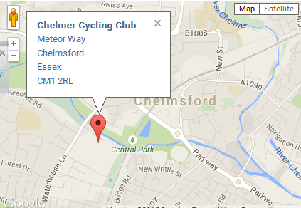

**Route from the race HQ and the start line:**

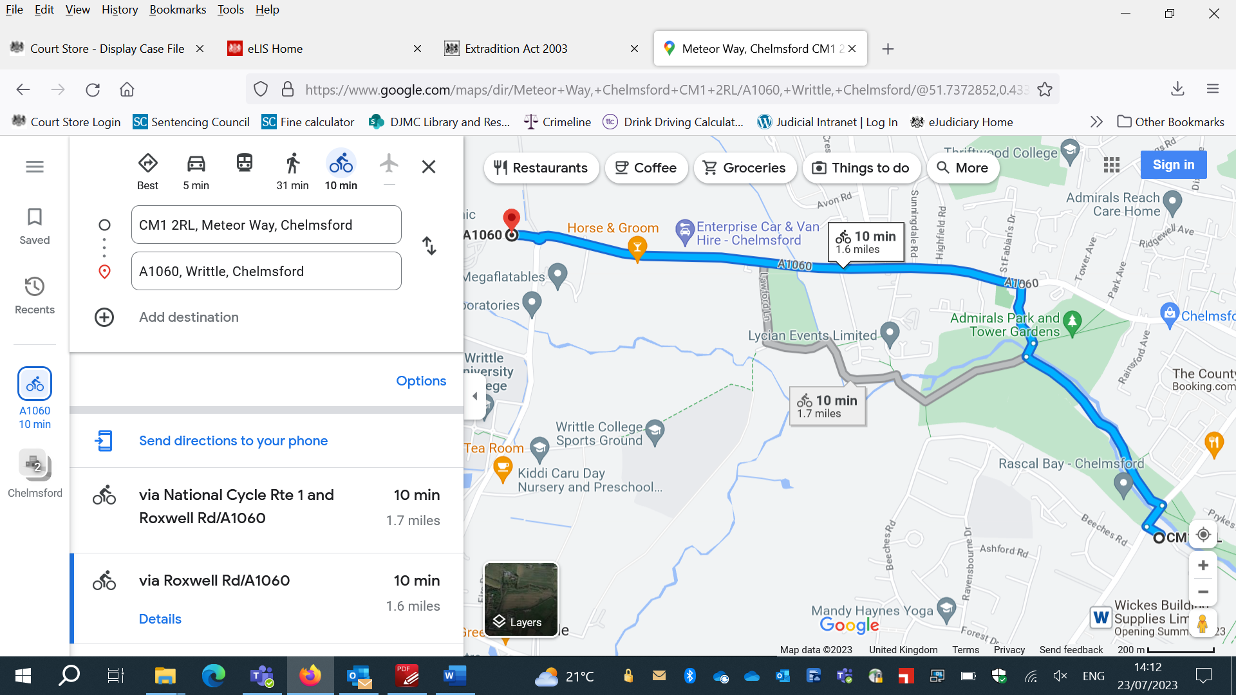

**To get to the start line:** Exit Meteor Way and turn right up the main road (Waterhouse Lane). Ride through the first main lights keeping in the left hand lane, and proceed to the next set of traffic lights. At that second set of lights, turn left along the A1060 signposted Leaden Roding, Sawbridgeworth). Keep following the A1060, to pass over the Writtle roundabout. The start area is just ahead. See map above.

**PLEASE** allow AT LEAST 10 MINUTES to ride from HQ to the Start Area

**PLEASE** avoid entering/warming up on the course – ample roads on the way to the start that riders can use to warm up. REMINDER warming up on the course is prohibited entirely after the event has started.

**HQ:** Toilet facilities are available at the Club Hut. Please use all facilities respectfully and mindful of other users.

**After the event:** please return to HQ for results and post event cakes and nibbles. Complimentary hot or cold drink for each rider on return of race number. Selection of Cakes will be available to purchase. CASH ONLY.

**ROAD BIKE REGULATIONS:**

* **No aerobars/clip-ons or extensions**
* **No hands off the handlebars riding (with forearms resting in an aero position) i.e. no “puppy paws” position.**
* **Wheels – maximum rim depth of 90mm. No disc wheels.**
* **Helmets used in Road Bike category events must not cover the ears or have a tear drop/pointy style "tail", any helmet vents must not be covered or blocked. The helmet must not have been altered or had any element added or removed in terms of design or form but may be used as the manufacturer intended (e.g., sliding vents). It is prohibited to add a detachable cover to a helmet. The composition of the helmet material and its surface condition are not subject to any regulations. However, additions to the helmet are not allowed (cover, tape etc.).**

Skinsuits and overshoes **ARE** permitted.

**THERE WILL BE BOTH MARSHALLS AND OBSERVERS OUT ON THE COURSE CHECKING RIDERS AGAINST THE REGULATIONS.**

**ENJOY THE RACE!!!!!!**

**Start numbers and start times:**

